**DESTINY CHRISTIAN ACADEMY**



Parent / Student

Handbook

**2023-2024**

**Destiny Christian Academy**

Contact Information

This handbook contains general information regarding the Destiny Christian Academy (DCA) administration, procedures, and fees. DCA reserves the right to change items contained in this handbook. Effective dates for all changes are at the discretion of the Academy and may apply to each student enrolled at the time.

Table of Contents

I. General Information 8

A. Mission Statement 8

B. Foundation 8

C. Board of Directors 8

D. Vision Statement 8

E. Statement of Faith 9

F. Educational Philosophy 9

Educational Philosophy (continued) 10

II. Accreditation Statement 10

III. Annual Asbestos Notification 11

IV. Enrollment 12

A. Nondiscriminatory Policy 12

B. Enrollment Process 12

1. Obtain admission forms and information. 12

2. First Visit 12

3. Application 12

4. Student Testing 12

Enrollment Process (continued) 13

5. Decision on Enrollment 13

6. Registration 13

7. Parent Orientation 13

8. Probation Period 13

9. Admissions Priorities 13

Enrollment Process (continued) 14

10. Conditions for re-enrollment for the following school year: 14

C. Financial Fee Schedule 15

1. Registration 15

2. Tuition 15

3. Curriculum Fee 15

4. Materials & Technology Fee 15

5. Miscellaneous 16

6. School Lunch Program 16

7. Field Trip Fees: 16

8. Pace Replacement Fee: 16

9. Damage Fees: 17

10. Graduation Fee: 17

11. Fundraiser Fee Opt Out: 17

12. Above & Beyond Contribution: 17

V. School Supplies 17

VI. Discounts and Scholarships 18

A. Refer a Friend Discount 18

B. Pastors or Members of Destiny Church Discount 18

C. Military and First Responder Discount 18

D. Multi-Student Discount 18

E. Paid-in-full Discount 18

F. Employee Discount 18

G. ACE Scholarship 19

VII. Payment Policies 19

A. Commitment 19

B. Service Fees 19

C. Delinquencies 19

D. Prorated and non-refundable Charges 20

E. May Guarantor Review Meeting 20

VIII. Breakdown of Finances 20

IX. Withdrawal Guidelines 21

A. Withdrawal Procedure 21

1. Notification to Administration 21

2. Unused PACEs 21

3. Account Balances 21

B. Grounds for Dismissal 22

X. Parental Role and Participation in Education 22

A. Code of Christian Conduct for Students & Parents/Guardians 22

Code of Christian Conduct for Students & Parents/Guardians 23

(continued) 23

B. Parent meetings and fundraisers 23

C. Attendance 23

Attendance (continued) 24

1. Absences due to Suspension 24

2. Appointments and Early Pick-up 24

D. Attendance Policy Procedure 24

E. Tardiness 24

1. Definition of Tardiness 25

2. Consequences for Tardiness 25

F. Uniforms and Personal Appearance 25

Uniforms and Personal Appearance (continued) 26

1. General Guidelines 26

2. Girls 26

Girls (continued) 27

3. Boys 27

4. Not Acceptable Uniform Standard 27

Not Acceptable Uniform Standard (continued) 28

5. Uniform Policy Enforcement 28

Uniform Policy Enforcement (continued) 29

6. P.E. Dress Code 29

7. Dress Down Days Purchased or Earned Privilege 29

G. Homework 30

1. Student Responsibility 30

2. Parent Responsibility 30

3. Consequences for Incomplete homework or Unsigned Slips 30

H. Make-Up Work 30

I. Field Trips 31

J. Promotion to the Next Level 31

K. Music in the Classroom 31

L. Cell Phones, Smart Watches, Other Electronic Devices 32

M. Boy-Girl Relationships 32

1. No Public Displays of Affection 32

XI. Student Expectations 33

XII. Discipline Philosophy 33

XIII. Discipline Implementation 34

XIV. Bullying 36

XV. Prohibited Items 39

XVI. School Search Policy 39

XVII. General Information 40

A. School Hours 40

B. Early Release Hours 40

C. Before and After School Care Program 40

1. Fees 40

D. Parking/Drop-Off/Pick-Up 41

E. Automobile Policy 41

F. Weather Delays or Closures 41

G. Nursing Services and Medication 41

Nursing Services and Medication (continued) 42

Nursing Services and Medication (continued) 43

H. Asthma Medication 43

I. EpiPens 43

J. Special Needs Care 44

K. Food Allergy Policy 44

L. Illnesses 44

Illnesses (continued) 45

M. Students who become ill during the school day 45

N. Mandatory Reporting 45

O. Extracurricular Activities: 45

XVIII. Communication: A School and Family Partnership 46

A. Weekly Reports 46

B. Office Emails 46

C. Teacher Phone Calls 46

D. Parent / Teacher Conferences 46

E. Behavior Alert / Academic Alert 46

F. Meetings 46

G. Visits 47

H. Parent Concerns 47

I. PRO-CARE Family Portal 47

J. PRO-CARE Tuition Management 47

K. PRO-CARE Parent Alert 47

XIX. Merit System 47

A. Positive Performance Rewarded 48

B. Poor Performance or Misbehavior 48

C. Merit Money Annual Rule 48

D. 1000’s CLUBS 48

1000’s CLUBS (continued) 49

E. Honor Roll Requirements 49

1. Honor Roll 49

2. Principal’s Honor Roll 50

Principal’s Honor Roll (continued) 50

XX. Academic Information 51

A. High School Credits 51

B. High School Promotion Requirements 51

C. Graduation Requirements – 27 Credits* 51

Math 4 Credits 51

XXI. Pace Conversion Chart 52

XXII. Disclaimer 53

XXIII. Parent / Student / Staff Team Commitment Contracts 53

A. Parent Commitment 54

B. Student Conduct Commitment 55

C. Teacher / Monitor Conduct Commitment 56

# General Information

## Mission Statement

“Train up a child in the way he should go and when he is old he will not depart from it.” Proverbs 22:6

## Foundation

Destiny Christian Academy is a ministry of Destiny Church, Cheyenne, Wyoming.  The administration of the academy is submitted to the authority of the Pastor and the church board.  It is the intent of the administration to keep the policies of the academy within the hedges of the church.

## Destiny Church Board

The Board serves in an advisory capacity to the school administration. It assists in organizational planning, strategic planning, oversight over the school’s budget, evaluating school policies and programs and ensures that the school is aligned with the Mission Statement. Appointed members are selected by Destiny Church and serve at the pleasure of the Pastor and church board.

## Vision Statement

Destiny Christian Academy is established as a ministry of the body of Christ.  Its primary purpose is to team with parents in training children in Godly character and excellent academics in a safe and loving atmosphere.

A Christian academy is an extension of the Christian home in training youth in a Christian environment.  Attendance at this academy is a privilege and not a right.  Along with maintaining high academic standards, our goals are to train youth of every ability in the highest principles of moral character, self-discipline, individual responsibility, personal integrity, and good citizenship.  This academy stands without apology for high standards of morality and Christ-like behavior.  We are unashamed to teach the Biblical doctrines of self-discipline, respect for those in authority, obedience to law, and love for God, flag, and country.

## Statement of Faith

1.  We believe in one God, maker of all things and being in the trinity of Father, Son, and Holy Spirit.

2. We believe the Son of God, Jesus Christ, became incarnate, was begotten by the Holy Spirit, born of the Virgin Mary, and is true God and true man.

3. We believe the Bible, in its entirety, to be the inspired and infallible Word of God.

4.  We believe in the resurrection of the dead, the eternal life with God of the saved, and the eternal punishment for the lost.

5.  We believe in the personal salvation of believers by the grace of God through faith in Jesus Christ as Savior.

6.  We believe in the sanctification by the Holy Spirit, in personal holiness of heart and life, and in separation from the world.

7.  We believe in the baptism in the Holy Spirit (Acts 2:4) as distinct from the new birth, in the gifts of the Spirit listed in scripture as now available to believers.

8.  We believe in the Christian’s hope – The imminent, personal return of the Lord Jesus Christ.

9.   We believe that God created the human race male and female and that He has established marriage as a lifelong, exclusive relationship between one man and one woman (Gen. 1:27, Gen. 2:24-25).

## Educational Philosophy

1.  To provide educational excellence by offering individualized Bible-based education that challenges a student’s intellectual ability, while catering to the uniqueness of each student. This allows each child to reach his or her full potential while developing a better understanding of their curriculum as it relates to God’s Word.

2.  To provide an educational opportunity to draw students into a deeper and fuller understanding of God and the world He created. In turn this develops a closer and deeper walk with the Lord Jesus Christ.

## Educational Philosophy (continued)

3.  To encourage and develop basic Godly character traits in each child.

4.  To encourage and support a strong relationship between children, parents, and the body of Christ.

5.  To provide an opportunity for each child to thrive in their walk with the Lord Jesus both during and after attending Destiny Christian Academy.

6.  DCA further encourages every student to dedicate his or her life to Christ and to equip each child to become an effective member of the body of Christ.

# Accreditation Statement

Destiny Christian Academy is not regionally accredited however we use the Accelerated Christian Education (A.C.E.) curriculum.  A.C.E.’s flagship school, Lighthouse Christian Academy, offers a program through which students may earn an accredited diploma/transcript, while attending Destiny Christian Academy.

Lighthouse Christian Academy “has earned full accreditation with Accreditation International (Ai). Ai is recognized member in good standing with National Council for Private School Accreditation (NCPSA). Through Ai’s relationship with NCPSA, Ai’s accredited schools can participate in coaccreditation with Middle States Association of Colleges and Schools Commissions on Elementary and Secondary Schools (MSA-CESS). Ai is also a member of the International Alliance of Regional Accreditors by virtue of their recognized status with NCPSA.”[1] Parents who are interested in finding out more about the accredited diplomas should contact Destiny Christian Academy’s office.

Parents are encouraged to personally check with their local school districts or colleges in which their children are interested, to find out what the school or college’s particular policies are regarding admissions or transferring credits.

# Annual Asbestos Notification

**(Required by the Asbestos-Containing Materials in Schools Rule, 763.84(c) and 763.93(g)(4))**

*Asbestos* is a naturally occurring fibrous mineral, which until about 1980, was commonly used in building construction.  Asbestos will not burn, is an excellent insulator, has great tensile strength, is resistant to chemicals, is a nonconductor of electricity, and absorbs sound.  Examples of *asbestos-containing building material (ACBM)* are vinyl floor tile, sprayed-on acoustical ceiling material, pipe and boiler insulation, and roofing felt.  As ACBM deteriorates over time, or is disturbed by maintenance, renovation, or demolition activities, it may become *friable*, i.e., it is capable of being reduced to powder by hand pressure.

When ACBM becomes *friable*, asbestos fibers are released into the air.  Inhalation of these airborne, microscopic asbestos fibers has been proven to cause such fatal diseases as lung cancer, mesothelioma (cancer of the lining of the lung or abdominal cavity), and asbestosis (scarring of lung tissues).  Uncontrolled asbestos contamination in buildings has been, and remains, a significant environmental and public health issue.  In 1986, Congress enacted the *Asbestos Hazard Emergency Response Act (AHERA)* to require public and private, secondary and elementary schools to identify ACBM in their school buildings and take appropriate actions to control the release of asbestos fibers.  In 1987, the US Environmental Protection Agency finalized a regulatory program, which enforces the AHERA mandate.  These regulations are incorporated within the *Asbestos-Containing Materials in Schools Rule* (40 C.F.R. Part 763, Subpart E).

In compliance with the *Asbestos-Containing Materials in Schools Rule*, Destiny Christian Academy had its school building inspected by an asbestos inspector, accredited by the State of Wyoming.  During that inspection, areas of suspect ACBM were identified.  The type, condition, and location of this ACBM were noted.  Samples confirmed the presence or absence of ACBM.  Suspect ACBM not sampled and analyzed were assumed to contain asbestos.  Confirmed and/or assumed ACBM currently remain in certain locations in our school building.

Upon confirmation of the presence of ACBM, an Asbestos Management Plan was developed for the school building of First Assembly Christian Academy by an asbestos management planner, accredited by the State of Wyoming.  *The Asbestos Management Plan includes a description of the measures currently being taken to ensure that the ACBM remaining in our school building is maintained in a condition that will not pose a threat to the health of our students and employees.*  This Plan describes past response actions taken to abate ACBM, as well as response actions planned for the future.  The Asbestos Management Plan provides information on the periodic monitoring of the condition of ACBM remaining in our school building through triennial re-inspections, conducted by accredited asbestos inspectors, and through semiannual surveillance, conducted by trained school or church staff.

A copy of the Asbestos Management Plan is available for your review in the Destiny Christian Academy administrative office during regular office hours.  The church has a designated Asbestos Program Coordinator for the School.  Please direct all inquiries regarding the Asbestos Management Plan to the school office at 307-635-3759.

# Enrollment

## Nondiscriminatory Policy

Destiny Christian Academy admits students of any race, color, and national or ethnic origin to all the rights, privileges, programs, and activities generally accorded or made available to students at the school. Enrollment in DCA is a privilege, and DCA reserves the right to suspend or expel any student, without refund, in accordance with set policies determined by DCA and Destiny Church Board.

## Enrollment Process

### Obtain admission forms and information.

Please obtain the admission forms either in person at the school office or on the website.

### First Visit

Parents, non-parent guardians, custodians, and the student(s) are welcome to meet with a member of the administrative staff to acquaint the family with our personal application of the individualized curriculum and the special emphasis that makes Destiny Christian Academy’s ministry so outstanding. We encourage questions so each family has a complete understanding of what we have to offer and the required school standards. A second visit may be requested for students in seventh grade and above.

### Application

For admittance consideration, all application forms are acquired, completed and submitted with the **non-refundable registration fee**. A list of all the forms required at the time of application is enclosed in the application packet.

*Kindergarten students must be five (5) years of age on or before the 15th day of September of the enrolling year. Younger students are admitted on a case by case situation. Or must be approved by the administrator.

### Student Testing

There are two to three ½ day sessions of testing for students enrolling in grades 1 – 12. The results of the students’ diagnostic testing can be crucial in helping both D.C.A. and parents decide if this academy is a good fit for the student.

## Enrollment Process (continued)

### Decision on Enrollment

Please keep in mind that D.C.A. is choosing its family partners, just like you are choosing which Christian school you would entrust your children to attend. This is important to maintain the quality that you are looking for in a Christian education ministry. Once we have received your completed application, our team will conduct a comprehensive review and notify you of our decision as soon as possible.

### Registration

All start-up fees must be paid at the time of enrollment. D.C.A. and parents will discuss convenient payment arrangements at this time.

### Parent Orientation

You will be notified of the mandatory Parent Orientation Meeting before the first day of school. This is a general meeting of all parents, non-parent guardians, custodians, to acquaint families with each other and to review school policies, etc. If your child is enrolled after the first orientation meeting, you will be required to attend the next scheduled orientation.

### Probation Period

All new students will be given a ninety-day trial period to prove himself / herself both socially and academically. If, during this trial period, situations arise that point to an incompatibility between the student/family and the school, a student may be asked to withdraw from the program.

### Admissions Priorities

### Destiny Church established DCA as a Christ -Centered school and priority will be given to those in the Body of Christ. Applicants who have siblings in the school or who are children of Staff members will also be given priority. Priority however will not be honored after one month has lapsed from open enrollment of DCA families. As space is limited, it is essential for families to get their registration information in before open enrollment.

## Enrollment Process (continued)

### Conditions for re-enrollment for the following school year:

* + - * Tuition payment needs to be current within a month of re-enrollment
      * Lunch and snack fees need to be current within a month of re-enrollment
      * Fundraising commitment must be met in current school year

## Financial Fee Schedule

### Registration

#### Non-Refundable $ 100.00 / student due with enrollment

### Tuition

K-8th grade         $3,100.00

9th-12th grade     $3,400.00

K-8th grade     9th-12th grade

1 Payment Yearly   $3,100.00       $3,400.00

2 Semester Payments     $1,550.00       $1,700.00

10 Monthly Payments    $310.00           $340.00

Yearly payments are due August 1st.

Semester payments are due August 1st and January 1st.

10 Monthly payments are due August 1st through May 1st.

### Curriculum Fee

**Non-Refundable and must be paid prior to the first day of school**

K-12th Grades     1 payment yearly

If paid by June 30     $350.00

If paid by July 31     $375.00

If paid on or after August 31       $400.00

### Miscellaneous

Lost/Failed Pace Replacement     $ 10.00

      Additional Subject     $ 50.00

      Additional PACE     $ 10.00

Placement/Diagnostic Test     $ 25.00

      Iowa Standardized Testing     $ 50.00

      Graduation     $150.00

      High School Transcript Copies     $ 5.00

### School Lunch Program

At Destiny Christian Academy, children have the option to purchase a hot lunch in the morning or to bring their own lunch from home. Microwaves are available for student use. (Please nothing over 3 minutes) Each class has ample time in the lunchroom; please see your child’s supervisor for your child’s lunch time.

Any parent wishing to take their student to lunch off-campus must come into the office and sign out their child. Upon returning, the student must be signed back in at the office.

Pre-paid lunch punch cards are available for purchase in the office. **Hot lunch menus with current pricing are posted on the website for your convenience.

### Field Trip Fees:

If there are any fees for a field trip (lunch money, admissions, etc.) this should be paid on or before the day of the trip, as the coordinator of the trip deems appropriate.

### Pace Replacement Fee:

After three days of a PACE not being at school, it will be considered lost and the PACE will be replaced.  If a student fails a PACE, a new PACE is issued and the student will retake the PACE. In either of these situations, a **$10 replacement fee** will be added on the next month’s bill.

### Damage Fees:

Students who cause damage by wrongful actions are charged with the replacement value of what is damaged, payable immediately.

**\*Note: This includes damage to chairs, flags, bathroom graffiti, downloading inappropriate computer programs (games etc.)**

### Graduation Fee:

For those students that will be graduating high school, parents will be billed the $150.00 graduation fee in March.  This fee includes:  graduation ceremony, diploma, cap, gown, and tassel. This is a non-refundable fee.

### Fundraiser Fee or Opt Out:

$500.00 fee per family opt out, or mandatory participation in all fundraisers ($125 minimum four times a year).

### Above & Beyond Donation:

This is an opportunity for any amount paid above the required tuition to receive a tax-deductible contribution. This contribution will help offset the difference between the actual cost to educate a student and the set tuition amount. Any amount contributed would not be applied towards your tuition, fees, or fundraising requirements, but rather would be a contribution towards the school’s operating costs or capital expenditures. A tax statement will be provided for any additional contributions made. Please consult your tax advisor for rules on charitable contributions.

# School Supplies

Student supply lists can be accessed on the school website and must be purchased at the beginning of the school year. Please keep in mind that a designated portion of these supplies are dealt with as donations and are integrated into the school’s general inventory. Therefore, we are unable to return designated supplies should a student withdraw after the start of the school year.

# Discounts and Scholarships

The following scholarships and discounts are offered to assist families with **tuition** at Destiny Christian Academy.

## Pastors or Members of Destiny Church Discount

This discount is offered to current Pastors, Destiny Church staff, Destiny Church members. A 5% discount per family is given with verification, at the start of the school year.

## Military and First Responder Discount

The Academy has a long-standing commitment to demonstrating our gratitude to members of the military, veterans, current law enforcement, first responders, and their families through our military and First Responder discount. A 5% discount per family is given with verification, at the start of the school year.

## Multi-Student Discount

For families with more than one student attending Destiny Christian Academy, the following discounts are offered.

2nd Child 10%

3rd Child 20%

4th Child 20%

## Paid-in-full Discount

In order to qualify for this discount, families need to pay the entire **tuition** for the academic year by August 1.

Discount per Family 5%

## Employee Discount

In recognition of our hard working employees, we offer an employee tuition / curriculum discount. This fringe benefit is part of our employee retention program.

## ACE Scholarship

ACE Scholarship helps low-income families from a variety of different circumstances across multiple states. To qualify for an ACE scholarship, a family must meet the income requirements for the Federal Free and Reduced Lunch Program. For information on how to apply, please contact the School Office.

# Payment Policies

## Commitment

By enrolling at D.C.A., the legal guardian has chosen to partner with the school in training the student.  Remember that you have COMMITTED to support those that share your responsibility.

## Service Fees

A $25.00 service charge will be added to your account on all returned or resubmitted checks.  If two checks are returned or resubmitted within the school year, cash, money order, or cashier’s check will be required to make future payments.

Payments not made by the 11th of the month are delinquent and a late charge of $25.00 or 10% whichever is greater on the amount due will be added to the account.

## Delinquencies

The schedule for contacting delinquencies is as follows:

Due 1st day of Month

Late fee letter after 11 days $25.00 or 10% whichever is greater

Conference After 20 days

“No Return” letter After 30 days

A tuition account that remains delinquent past the 30th of the month it was due, will result in your child or children being excluded from school until the balance is paid.  Destiny Church Board will handle any exceptions.  If the account is turned over to collections, your child or children will be ineligible for future enrollment at D.C.A.

## Prorated and non-refundable Charges

For families that enroll or withdraw after the school year begins, charges and fees will be prorated according to the actual number of days enrolled.  Other conditions are as follows:

##### Registration and curriculum fees are non-refundable.

##### Items purchased for the student’s use will be paid in full.

##### PACE’s and all academic material are the property of the academy and any unused PACE’s will not be given to the families.

##### One-week notice is required for copies of final records.

## May Guarantor Review Meeting

All families will be required to meet with office staff every May to review the upcoming school year payment options. These meetings will be set up by the school with each family.

# Breakdown of Finances

The following is an itemized breakdown of where your money goes:

**Registration Fees:** Staff Training

**Curriculum Fee:**  PACES, books, educational materials, 1000’s Clubs, and awards

**Materials & Technology Fee**: Security cameras, software, computer programming and security guard.

**Tuition:**  Salaries, utilities, operation expenses, supplies, etc.

**Miscellaneous fees:**  Covers the cost of those activities

**Dress Down Days** Merit Store items

**Fund-raiser monies:**  Applied where needed

**Above & Beyond Contribution:**  Operational & Capital Expenditures

# Withdrawal Guidelines

Upon the withdrawal of any student, all other amounts to/from the school shall be settled, including: tuition balance, lunch account, extended care account, fines, fees, assessments and fundraising obligations (which are pro-rated through the withdrawal date). **The net amount shall be paid to (refunded by) the school no later than 45 days after the withdrawal date.**

## Withdrawal Procedure

### Notification to Administration

DCA requires that parents give, in writing, 30 days notification that a student is being withdrawn.  The parent is required to continue paying tuition fee until the 30 days has been met.  Tuition will not be prorated if the student is withdrawn after the 1st of the month.

### Unused PACEs

PACEs and all academic material are the property of the academy and any unused *PACEs* will not be given to the families.  Curriculum fees are non-refundable.

### Account Balances

All account balances must be paid in full and all curriculum resources borrowed must be returned to the academy for the release of records. The school will not forward records for students who withdraw with an outstanding balance.

If you are set up with automatic payment, any balance due will be taken as authorized from the account on file within 45 days after withdrawal. These fees would include balance of tuition, fundraising, lunch, extended care, and any damages to school property.

## Grounds for Dismissal

The school reserves the right to dismiss or deny re-admission to students for the reasons the administration deems fit, such as the following:

* Failure to fulfill financial obligations
* Nonconformity to standards
* Lack of parental cooperation
* Inability to respond to individualized curriculum
* Bullying

# Parental Role and Participation in Education

## Code of Christian Conduct for Students & Parents/Guardians

It shall be an express condition of enrollment that the student behaves in a manner, both on and off campus that is consistent with the principles of the school as determined by the school in its discretion. These principles include, but are not limited to, any policies, principles, or procedures set forth in any student/parent handbook of the school.

Students are expected to act in an orderly and respectful manner, maintaining Biblical standards of social courtesy, moral behavior, acceptable language, and honesty. Destiny Christian Academy maintains a necessary 6-inch personal space rule.

Students are expected to refrain from talking about or engaging in cheating, swearing, and sexual activity.  Students are also expected to refrain from illegal activities such as smoking, vaping, gambling, drinking alcoholic beverages, using narcotics, and communicating in a manner that is inappropriate (verbal, text, email, etc.).  Students who participate in and/or discuss such activities at school will be subject to disciplinary action possibly including suspension and/or expulsion. If such behavior occurs outside our school and is brought to our attention, those students will be subject to disciplinary action, possibly including suspension and/or expulsion. **Students must agree to strive toward unquestionable character in dress, conduct, and attitude.**

## Code of Christian Conduct for Students & Parents/Guardians

## (continued)

When a child’s attitude and conduct are not in accord with school policies or principles, the child will be placed on probation and both parents will be called for a conference.  If the administration feels the situation has not changed within a designated time, parents will be asked to withdraw the child.

It shall be an express condition of enrollment that the parents/guardians of a student shall also conform to the standards of conduct that are consistent with the Christian principles of the school, as determined by the school in its discretion.

## Parent meetings and fundraisers

By enrolling in D.C.A. **parents are COMMITTING** themselves to attend those functions that are essential to communication:

**A)** All parent meetings.

**B)** **Parents and students will be expected to participate in all fundraisers.**  The academy plans about 4 fundraisers per year.  DCA will offer parents the opportunity to opt out of a fundraiser for a fee (per family) of $500 for a service-based fundraiser yearly, $125 for a sales-based fundraiser and yearly $500.

## Attendance

Attendance is one of the most basic requirements for academic and future workforce success. Parents will be held accountable to adhere to the attendance policy in order to ensure that students are getting the classroom hours they need to succeed. Regular attendance is required and poor attendance will not be tolerated.

Parents or guardians are expected to ensure that students are at school every day, on time, and in the school uniform. Every effort should be made to schedule appointments after-school hours or on days when school is not in session. Any student with five (5) or more unexcused absences in one school year will be considered “habitually truant” as defined by Wyoming Statutory Law.

Ten (10) consecutive unexcused absences will lead to automatic disenrollment.

Any illness after 3 consecutive days will require a doctor’s note. The Principal reserves the right to request a doctor’s note and/or any other documentation for verification purposes.

### Absences due to Suspension

Absences due to suspension or expulsion shall be considered excused absences and will not be included in the count for habitual truancy per Wyoming statute.

### Appointments and Early Pick-up

Students are expected to stay in school until the end of the school day (2:45 p.m.) for regular dismissal. It is very disruptive to the learning environment when students leave school early. Therefore, students will not be called until 2:45 p.m. for the car lane. Please be patient as the students are called in order of the car lane.

No student will be permitted to leave the Academy at any time before the regular hour of dismissal without written permission from their parents (this includes students who drive themselves to school.)

## Attendance Policy Procedure

If a student will be absent, the parent is required to CALL/text their Teacher by 8 a.m. or the office by 10:00 a.m. to inform the administration and supervisor of the absence.  A student is considered absent when not in school for the entire day or arriving to school at 11:00 a.m. or later.

## Tardiness

Statistically speaking, tardiness is one on the most common reasons why people lose their jobs in the workforce. Getting to school on time is another key to academic success. Students, who arrive late to school will likely miss academic instruction, lunch count, disrupt the classroom, and distract other students.

School is your student’s job, in which they learn and grow academically, emotionally, socially, and spiritually. As your partner, the Academy seeks to promote professionalism and good work ethic into our students. This will help prepare students for the rigors of college and becoming a positive contributing member of society.

### Definition of Tardiness

Students must arrive to school between **7:45 a.m. and 8:15 a.m.** every morning that school is in session. If a student is late to school, the **parents must** come into the office and sign him/her in. Otherwise the student may be marked as absent.

### Consequences for Tardiness

Excessive tardies coupled with unsatisfactory academic performance may lead to mandatory loss of in-school privileges at the discretion of the Principal. The Principal will call the student’s parents to discuss the problem and develop a corrective plan

## Uniforms and Personal Appearance

At Destiny Christian Academy, it is our belief that the physical appearance of our students is an essential element in developing personal responsibility. All students Kindergarten through 12th grade are required to wear uniforms. School uniforms are to be worn each school day unless a special dress day has been designated. The school reserves the right to identify styles or colors of clothing as disruptive to the educational setting.

Uniforms are important as they provide uniformity, thus reduce distractions and clothing competition. This instills equality and is a visual representation of the school community and the virtues and expectations that the students are expected to live up to. Additionally, it mentally prepares the student for the day when they come “dressed for work.”

Personal hygiene is important not only to your student, but also to the other students and staff. Please ensure your child has eaten breakfast, brushed their teeth, brushed their hair, washed their face, and bathed when necessary. This teaches a good hygiene routine and the future requirement for most employers. If your child needs some personal attention, the school will notify the parent by phone or email.

Parental support of these guidelines is extremely important. It is the specific responsibility of each parent/guardian to ensure that the student leaves home clean and dressed appropriately in accordance with these regulations. If a student arrives at school and is out of uniform, parents will be called and asked to bring in a uniform before the student is sent to class.

## Uniforms and Personal Appearance (continued)

### General Guidelines

* Clothing must be neat, clean, modest, hemmed, and SIZE/LENGTH APPROPRIATE.
* Any item of outerwear may be worn to school, but the DCA uniform shirt must be able to be clearly seen in the classrooms and hallways.
* **SWEATSHIRTS, FLEECE JACKETS (exception DCA purchased fleece jacket), FLEECE VESTS, AND HOODIES** are acceptable for **OUTSIDE AND RECESS ONLY.**
* Pullover type jackets and sweatshirts are not allowed over uniform shirts. Sweatshirts with the DCA logo or name on them are acceptable.
* Shirts are purchased directly from the academy.
* Proper undergarments are to be worn at all times.
* Appearance must be NEAT and CLEAN at all times.
* Clothing should be in good repair.
* Students wearing snow boots to school must have a pair of regular shoes (no flip flops) to change into upon arrival.

### Girls

* **SKIRTS** must be black, navy blue, khaki, or grey and no more than 2 inches above the knee (approximately the width of 3 fingers). Leggings or shorts must be worn under the uniform skirt.
* **UNIFORM SHIRTS** – must be worn each school day, unless the student has earned a Privilege Status, and they must be clean and neat. No bulky clothing may be worn underneath the uniform shirt.
* **BELTS –** are encouraged when needed.
* **PANTS** must be black, navy blue, khaki, or grey. **No Leggings or Jeggings are permitted.**
* **SHORTS** must be black, navy blue, khaki, or grey and must be no more than 2 inches above the knee.
* **SHOES** dress or tennis shoes must have laces, straps or Velcro – No slip-on shoes. **Tennis shoes must be worn for P.E**

### Boys

* **PANTS** must be black, navy blue, khaki, or grey.
* **UNIFORM SHIRTS –** must be worn each school day unless the student has earned Privilege Status, and they must be clean and neat. NO bulky clothing may be worn underneath the uniform shirt.
* **BELTS** must be worn (starting in grade 2) and should be brown or black only and completely visible.
* **SHORTS** must be black, navy blue, khaki, or grey and must be no more than 2 inches above the knee.
* **SHOES** dress or tennis shoes must have laces, straps or Velcro – No ship-on shoes. **Tennis shoes must be worn for P.E.**

### Not Acceptable Uniform Standard

* No bulky long-sleeved shirts worn under uniform shirts.
* Writing on shoes, clothing or body.

### Not Acceptable Uniform Standard (continued)

* Jewelry: Must be modest and subject to the Principal’s discretion.
* Hats/caps/scarves/bandanas or other headgear/sunglasses inside the building.
* Extreme types of haircuts and/or colors are not permitted. Hair must be **clean** and **neatly groomed**.
* Facial hair (beards, mustaches, long sideburns) **must be clean!**
* Clothing that is not properly sized. Form-fitting tops that reflect the imprint of undergarments are unacceptable. Pants/slacks and tops must overlap enough to avoid exposing the midriff when normal movement such as stooping, stretching, etc. occur. Boys’ shirts must be long enough to tuck into his pants or shorts.
* Stained, dirty and/or frayed clothing/shoes with holes or patches.

### Uniform Policy Enforcement

The uniform policy will be strictly enforced. The following consequences will be applied to uniform policy infractions. The principal may make the determination of the consequence based on the age of the student.

### Uniform Policy Enforcement (continued)

**Missing/Incorrect Uniform Consequences**

**1st Violation:** A verbal warning will be given to the student

**2nd Violation:** Student may lose privileges, a note will be sent home, and/or the student will call the parent.

**3rd Violation:** A note will be sent home and/or the student will lose privileges and the student will call the parent.

**4th Violation:** Student will lose privileges and parent will be required to bring the correct uniform pieces to the school

### P.E. Dress Code

Middle to high school students are required to change into gym clothes. Gym clothes include athletic pants or shorts (2 in. rule applies) and a t-shirt or sweatshirt. Tennis shoes which fasten securely must be worn. Gym clothes must be taken home and washed at the end of the week.

Students are advised to bring deodorant and may also bring body spray for use during and after PE. Tennis shoes and socks must be worn for P.E.

### Dress Down Days Purchased or Earned Privilege

Students may wear non-uniform clothing that is clean, neat, and in good repair. Skirts and shorts will meet the same length requirement as the uniform skirts and shorts. T-shirts will not have any inappropriate pictures or text.

Clothing must cover all areas when a student’s hands are raised above their heads. Clothing should not be form fitting to the body (jeggings/leggings). Shirts should not come below the collar bone or show cleavage. Pants should not show skin or undergarments, and must be in good repair (NO HOLES). Students who repeatedly violate the free dress policy will be denied participation in the next Dress Down Day.

## Homework

Homework is assigned if the student did not complete all their assigned learning goals in class. It is an essential part of the school’s educational program designed to keep each student on track to complete the required 12 PACEs per year in each subject.

### Student Responsibility

Students will be held accountable to ensure that homework is complete, clean, and thorough. Since each student has different capabilities and interests, it would be difficult to denote the specific amount of time to be spent on assignments. Three incomplete, unexcused Homework Assignments in a week will result in an **In-School Suspension**.

### Parent Responsibility

Parents or guardians **must sign** the homework slip! Incomplete homework or unsigned homework slips are serious and will result in making up the assigned work, demerits, loss of in-school privileges, detention, and possibly suspension at the discretion of the Principal.

### Consequences for Incomplete homework or Unsigned Slips

Unexcused, incomplete homework or unsigned homework slips are serious and will result in making up the assigned work, demerits, loss of in-school privileges, detention, and possibly suspension at the discretion of the Principal.

## Make-Up Work

After returning from an absence, students are expected to meet with the teacher to establish a plan for making up missed goals. Parents will be included in this plan. This keeps the student on track to complete the required PACEs in each quarter.

In the event of a planned absence, parents must notify the office, Principal, and classroom teacher as soon as possible. This will allow time for the staff to prepare the learning goals for the student to complete during the absence.

## Field Trips

Field trips are designed to enhance academic units and all grades do not always have the same number of field trips.

Field trips are permissible for all grades when advanced planning, location, and the experience ensure a successful learning opportunity. Completed permission slips are required for every field trip.

The Academy reserves the right to restrict or deny student participation on any field trip due to, but not limited to, poor academic performance and/or poor conduct.

## Promotion to the Next Level

Destiny Christian Academy maintains high standards in accordance with A.C.E. School of Tomorrow guidelines for academic promotion. Neither parents nor students should assume that a student will pass from one grade level to the next. The student must earn promotion by demonstrating mastery over the required academic content in all subject areas. The Administration may recommend the repetition of a PACE, or a series of PACEs, tutoring, or summer school classes in order to meet the requirement for promotion to the next grade level.

## Music in the Classroom

Although music has been shown to improve learning, it is equally disruptive to some students. Therefore, if music is played in the classroom, only the teacher or monitor will have access to the device. It will be low volume and only instrumental or classical music will be played.

Should a student earn a privilege of playing their own music, it must be approved, maintain low volume, headsets or ear buds must be worn, and no disruptive movements will be allowed. If a student breaks any of these rules or becomes disruptive to other student’s learning this privilege will be revoked.

The Principal reserves the right to change or remove this privilege if it becomes counter-productive to students learning.

## Cell Phones, Smart Watches, Other Electronic Devices

Students are not allowed to use cell phones, smart watches, or other electronic devices during school hours (8:00 a.m. – 3:00 p.m.). All student cell phones and smart watches are required to be surrendered and placed in the class lockbox upon arrival, and must remain there until dismissal. This is to protect other students from watching or listening to inappropriate content during school hours and while under the Academy’s care.

If a student tries to hide a cell phone or if a cell phone is found on the premises during school hours, it will be confiscated and held by the Principal or Executive Secretary until the parent comes to the school to pick it up. Disciplinary consequences may be given to the student for dishonest behavior at the discretion of the Principal. Students will be able to make phone calls when necessary using the front office phone.

The school is not responsible for any incidents that arise due to social media usage outside of school hours. If cyber-bullying between students occurs outside of school, the school is not obligated to issue punishment. However, the Academy expects students conform to the standards of conduct that are consistent with the Christian principles of the school both during school hours and out of school. Disciplinary action may be taken as determined by the school in its discretion.

## Boy-Girl Relationships

We believe God’s plan is for boys and girls to have activities and fellowship together, learning much about each other in general, always holding the other up in the highest respect, and functioning as sisters and brothers toward each other as members in the larger family of God.  Boys and girls can trust God to bring them together with the one of His choice for a period of Christian courtship, while they continue to seek Him about their relationship.  Therefore, we expect our students to be open to Godly instruction in this area and to conduct themselves in a manner pleasing to God.

### No Public Displays of Affection

Practically applied, there is to be no public display of affection. This means students should maintain the Academy’s 6-inch rule, no hand holding, embracing, kissing, touching each other affectionately, during school, at any school activities, or on school premises.

# Student Expectations

Students are expected to abide by the school norms and accept the consequences if they break the rules. Rules are intended to promote Christian principles to be responsible, safe and respectful. The Academy provides each student with the maximum opportunity to acquire an education. No student has the right to interfere with the opportunity of other students by his/her actions, poor manners, or lack of consideration. This applies on the school ground, going to and from school, and at any event where the school is represented, regardless of location.

Success of any program depends on the implementation of all partners (school personnel, parents / guardians, and students). Follow-through and support by parents / guardians at home with consistent application of the guidelines is essential for the success of the student.

# Discipline Philosophy

Destiny Christian Academy is not a disciplinary facility; consequently, we ask that a student not be enrolled with the idea that he/she will be reformed. The Academy is a partnership and we are here to work with the home, but not to take the place of parents who have experienced difficulty with their child’s behavior.

Destiny Christian Academy believes discipline in our lives is essential to learning, growing and applying God’s principles.  Proper DISCIPLINE is part of DISCIPLING.

All staff members have the right AND responsibility to hold students and staff members, that come under their authority, to proper behaviors and attitudes.

The Academy believes in administering discipline that brings correction to behavior rather than simply punishment.  All discipline meted out should be done in love, not in anger.

# Discipline Implementation

Discipline measures should fit the offense and tend to bring about the desired, positive behavior.  The classroom is a place where students relate to staff members and other students in a stable, peaceful and yet active atmosphere.

To achieve this type of atmosphere, the classroom operates on certain principles.

* The classroom is a quiet, yet active place of learning.
* Students are to be kind and considerate to others.
* Students are to be obedient.
* Academic success depends on using the system rather than beating the system.

Violations of these principles result in the student receiving demerits, which are warnings.  If demerits accumulate, meaning repeated or several violations, the student is held accountable for his actions by corrective measures meted out.

Among these measures are detentions, loss of privileges or privilege status, or 1 to 3-day suspensions, depending upon the seriousness of the violation.  If all discipline measures have been exhausted and the student has not shown the desired behavior change, an expulsion recommendation will be given to the board.

Possible violations can include the following:

* Disturbance in class, talking to other    students, making noises, playing with toys, wasting time.
* Not doing an assigned task, acting in defiance, talking back, or being in an off-limits area.
* Failure to comply with PACE procedures, not getting proper initials when necessary, not complying with room procedures.
* Pushing, punching, yelling, arguing, talking badly about others or talking badly to others.
* Not demonstrating good sportsmanship during P.E., recess, lunch break or any other activity that involves some level of competition.

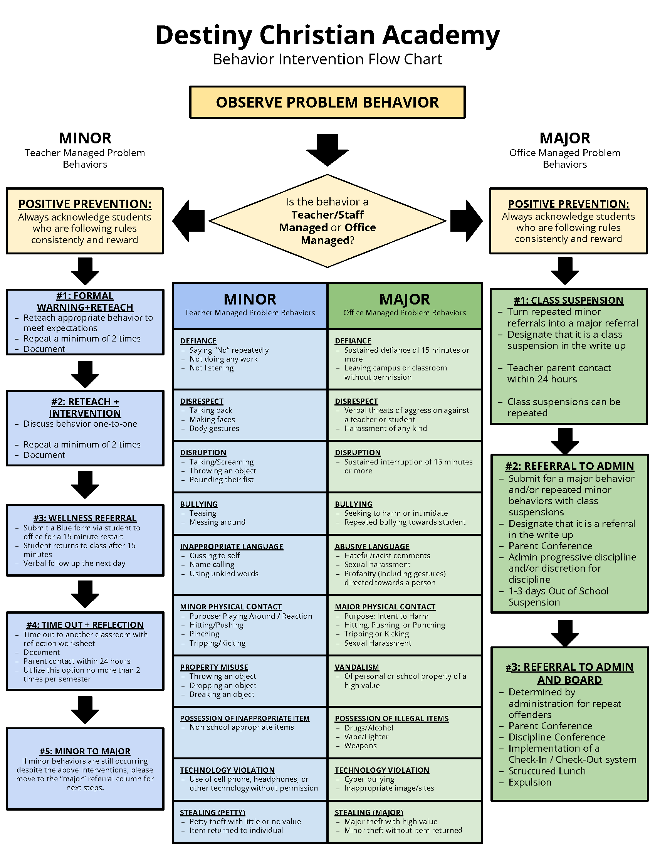

# Bullying

If a student is bothered by another student, he / she should inform the teacher or another adult right away. As soon as possible, the teacher will follow up on the report and take action as needed to resolve the conflict. Parents with a concern are encouraged to contact the student’s teacher or Principal to set up a meeting.

Bullying is an ongoing and deliberate misuse of power in relationships through repeated verbal, physical and/or social behavior that intends to cause physical, social and/or psychological harm. It can involve an individual or a group misusing their power, or perceived power, over one or more people who feel unable to stop it from happening.

Students who are determined to have engaged in the various forms of conduct referenced here will be subject to progressive discipline, suspension from participation in school-related activities and privileges, to disciplinary sanctions, up to and including expulsion.

**Types of Bullying**

**There are many forms of bullying but those listed below are identified as the most common.**

**Destiny Christian Academy**

**Bullying Escalation Chart**

|  |  |  |  |  |
| --- | --- | --- | --- | --- |
|  | **Procedures** | **Documentation** | **Interventions** | **Rewards / Consequences** |
| **Bullying** | Investigation  Administration  Meeting Parent Contact | Witness Statements  Discovery | Ongoing Monitoring  Limiting interactions with victim | Suspension  Referral to Safe School |
| **Bullying with an aggravating component** | Investigation  Administration  Meeting Parent Contact | Witness Statements  Discovery | Ongoing Monitoring  Limiting interactions with victim | Suspension  Referral to Safe School  Referral to Law Enforcement |
| **Cyber-bullying** | Investigation  Administration  Meeting Parent Contact | Witness Statements  Discovery | Ongoing Monitoring  Limiting interactions with victim | Suspension  Referral to Safe School  Referral to Law Enforcement |
| **Hazing / Harassment** | Investigation  Administration  Meeting Parent Contact | Witness Statements  Discovery | Ongoing Monitoring  Limiting interactions with victim | Suspension  Referral to Safe School  Referral to Law Enforcement |
| **Mutual Altercation** | Investigation  Administration  Meeting Parent Contact | Witness Statements  Discovery | Ongoing Monitoring  Limiting interactions with victim | Suspension  Referral to Safe School |
| **Verbal aggression using “fighting words”** | Investigation  Administration  Meeting Parent Contact | Witness Statements  Discovery | Ongoing Monitoring  Limiting interactions with victim | Suspension  In School Suspension |
| **Retaliation** | Investigation  Administration  Meeting Parent Contact | Witness Statements  Discovery | Ongoing Monitoring  Limiting interactions with victim |  |

**D.C.A. Bullying Escalation Chart**

**D.C.A. Support for targeted Students**

**D.C.A. Support for Perpetrator**

# Prohibited Items

Items such as, but not limited to, questionable books and pictures, knives, guns/weapons, matches, cigarettes, laser lights, or anything that will detract from a learning situation or create an unsafe situation are not allowed at school at any time. Items taken away from students will be returned only to the parents / guardians.

# School Search Policy

Searches for suspicion of illegal or unauthorized materials or content can be conducted at any time in the following areas: Student offices, student lockers; and when these items are on school property: backpacks, purses, pockets, and person.

# General Information

## School Hours

Grades K-12 Monday – Friday

School begins at 8:00 a.m.

School dismisses at 3:00 p.m.

## Early Release Hours

School begins at 8:00 a.m.

School dismisses at 11:00 p.m.

## Before and After School Care Program

The Academy’s extended care program operates on full school days. On early release days (release time is 11:00 a.m.), the Academy **only offers Morning Care**.

If desired, morning care will provide breakfast for students and after care will provide a snack.  Additionally the student will have opportunities for homework help, participate in organized games, FREE play, and other learning opportunities.

### Fees

*School pick up is between 3:00 p.m. and 3:15 p.m., and any children not picked up by 3:15 p.m. will be taken to the after-care program.  The parent or guardian will be billed the drop-in price of $10 (per child) for up to 2 hours, until 5:15 p.m.

**If a child is in an after-school club and is not picked up within 15 minutes of club dismissal, the child will be taken to the aftercare program and be charged $10 (per child).

|  |  |  |  |
| --- | --- | --- | --- |
|  | **1 Student** | **2 Students** | **3 Students** |
| **Before Care**  6:30 a.m. – 7:45 a.m. | **$ 7.00** | **$ 12.00** | **$ 15.00** |
| **After Care**  3:15 p.m. – 5:30 p.m. | **$ 10.00** | **$ 17.00** | **$ 22.00** |
| **Both** | **$ 17.00** | **$ 29.00** | **$ 37.00** |

**\*Late Fee** – If your child is not picked up by 5:30 p.m. you will be charged a late fee of $2.00 per minute per child per day. Please call, if you are going to be late.

## Parking/Drop-Off/Pick-Up

Parking is available on the East side of the building in the parking lot.  Please use this lot whenever you have business in the academy.

When picking up your student, pull up in front of the triple doors on Eighth Street on the school side of the street.  PLEASE DO NOT PARK SO THAT CHILDREN HAVE TO CROSS THE STREET!  ELEMENTARY STUDENTS **WILL NOT** BE RELEASED TO CROSS THE STREET!Do not double park; please wait as the line of cars moves forward.

## Automobile Policy

No student may drive to school without a valid Wyoming driver’s license and proof of insurance on file in the academy office. All parents driving for any academy functions must have a valid Wyoming driver’s license and carry proof of insurance in vehicle.

Student parking will be determined at the beginning of each school year. Students and parents will be notified as to where student parking will be located.

## Weather Delays or Closures

Please see the Academic Calendar posted on the website for the scheduled school days and closures for the academic year.

Destiny Christian Academy will generally defter to the Laramie County School District 1 with regard to school delays and closings. In the event of additional delays or closures that LCSD #1 has not initiated, you will receive an ALERT using the FACTS Parent Alert mass communication system.

If the school determines it necessary to close, students will take home their PACES in anticipation of the closure. Student / teacher check-ins are required to ensure students are completing their goals accordingly.

## Nursing Services and Medication

Destiny Christian Academy does not have a nurse on staff to provide nursing services for students. However, students will be sent to the office for various low urgency issues for proper triage. Parents will be notified of any cause for concern, as determined by school personnel, and are expected to promptly communicate with the school about any medical conditions the student may have.

## Nursing Services and Medication (continued)

In case of an accident, first aid will be administered and, if necessary, parents will be contacted as soon as possible. In the event of an emergency, the school will first contact the paramedics before contacting the parents.

The State of Wyoming Health form is to be filled out, on or before the day your child starts school. A child must be properly immunized for enrollment in our academy. If you do not have a record of your child’s immunization or an immunization waiver, you will be given a two-week grace period. After this time, your child will be asked to leave school until it is received.

Destiny Christian Academy suggests annual check-ups. We urge students, especially when entering kindergarten, to have a thorough examination. We also urge parents to share any medical concerns with the academy staff, especially with his or her supervisor.

School personnel **WILL NOT BE PERMITTED** to administer medication of any kind without approval from the parent who must first complete an “Administration of Medication” form as required by the State Health Department. **This policy applies to all medicine, including aspirin, Tylenol, and other over-the-counter medicines.** All student medicines will be kept in a locked cabinet. The school will keep a detailed log of all medicines that are administered by the school’s staff.

If a child must take any medication in school which is prescribed by a doctor, that medication must be sent to the school office in the original container received from the pharmacy and must have on its label the following information:

#### Child’s name

#### Name of doctor prescribing the child’s medication

#### Frequency

#### Dose

#### Date

#### Name of medication

#### Possible side effects

#### Storage instructions

## Nursing Services and Medication (continued)

All NON-PRESCRIPTION medication should be taken to the school office with the following information:

#### Child’s name

#### Frequency

#### Dose

#### Date

#### Name of medication

**\*\*NOTE: The office will NO LONGER stock aspirin, Tylenol, and other over-the-counter medicines.** Cough drops should be kept in the child’s classroom with name, directions, frequency documented on them. Teachers will be responsible for distribution of cough drops.

**No medications, prescription or over the counter, will be administered to students without parent/guardian written permission. Parents must provide all medication including over-the-counter medicines.**

## Asthma Medication

Immediate access to rescue inhalers is vital for the health of the student. Children are encouraged to carry their inhaler as soon as the parent, doctor or nurse, and class teacher agree they are mature enough. These students will be allowed to carry their inhaler in a “fanny” pack for quick access.

**Parents are asked to ensure that the school is provided with a labeled (as outlined above) spare rescue inhaler.**

## EpiPens

All staff at the beginning of the year will be informed by the school office of the students who may need EpiPens. Students are allowed and encouraged to carry their EpiPen with them at all times. Written parental permission is required and parents will need to provide the EpiPen.

## Special Needs Care

Should a student require special care throughout the day (Example: Type 1 diabetic) a care plan meeting will be set up prior to school starting. During this meeting the school will need the written physician’s plan along with any additional information the parent / guardian can provide to assist in the care of the student. Parents will need to provide any supplies needed to take care of the student’s health issue.

## Food Allergy Policy

Life threatening food allergies are an important condition affecting many school children. Parents must provide Destiny Christian Academy with a physician’s notification of the allergies to help minimize the incidence of life-threatening allergic reactions.

The office will notify classroom teachers of the life-threatening allergies that are faced by our students. With the parent consent, information regarding the nature of the life-threatening allergies will be distributed to designated staff members. All medical information will continue to be confidential and shared on a need-to-know basis. Teachers will be responsible for keeping an updated substitute folder containing information that is required to provide care and safety.

## Illnesses

In order to promote wellness in our classrooms, **PLEASE KEEP YOUR CHILD HOME** if he/she has a highly contagious illness such as:

* Flu
* pink eye
* gastroenteritis
* Hand, Foot and Mouth Disease
* RSV
* Fifth Disease
* The Academy will follow the current CDC recommendations regarding positive cases or exposures to Covid-19.

## Illnesses (continued)

**PLEASE KEEP YOUR CHILD HOME** if they have any of the following symptoms:

* Diarrhea
* Severe pain or discomfort
* 2 or more episodes of acute vomiting within a period of 24 hours
* Difficult or rapid breathing
* Yellowish eyes or skin
* Running a fever of 99.6° F or greater
* severe coughing
* Untreated head lice or nits
* Untreated scabies

**PLEASE KEEP YOUR CHILD HOME** if they have any of the following symptoms: (continued)

* Children suspected of being contagious stages of chickenpox, pertussis, measles, mumps, rubella, or diphtheria
* Purulent conjunctivitis (pink eye)
* Greenish discharge from the nose

## Students who become ill during the school day

If a student becomes ill during the day, and requires exclusion from the classroom; he or she will be taken to the office. The parents will be notified and the child will be kept isolated from the other children until the child is picked up. **Students need to be symptom and fever-free for 24 hours before returning to school.**

## Mandatory Reporting

By state law, Destiny Christian Academy’s employees are required to report any form of suspected child abuse, neglect, or endangerment.

## Extracurricular Activities:

As scheduled

# Communication: A School and Family Partnership

Academic success for each student requires an effective partnership between the school and the parents and communication is an integral element. There are several ways that the school will communicate with parents throughout the year.

## Weekly Reports

A congratulation notice which lists the PACEs passed during the previous week.

Additional comments from the teacher to the parents.

## Office Emails

A monthly calendar with current activities, including fundraising and volunteer opportunities, the scripture passage to be memorized for the coming month and the lunch menu.

## Teacher Phone Calls

When necessary and appropriate, teachers will speak with each of their students’ parents over the phone to discuss student progress.

## Parent / Teacher Conferences

At the end of the first quarter, parents will be required to come to the school for conferences with their student’s teachers. Parents will receive a written Report Card at the conference. This is an important conference as addresses the student’s progress and needs. Additionally it sets the expectation going forward. If you are unable to attend the conference at the scheduled time, you should re-schedule with the teacher at a mutually acceptable time.

A second Parent Teacher Conference is offered in February and is at the request of either the teacher or parent.

## Behavior Alert / Academic Alert

If your student is experiencing a behavior or academic problem, the teacher and or the Principal will call to discuss the situation and plan of action. Occasionally this will require an in-person meeting and will be scheduled accordingly.

## Meetings

Please keep in mind that if the school requests a meeting with you and your student, it is because we need to address something important with you. If you would like to schedule a meeting with a teacher or the Principal, please contact the office or them directly.

## Visits

If you wish to visit the school, upon arriving, all visitors must sign in at the Office and be given visitor badges. Any disruptive visitors may be asked to leave. If a visitor is coming to school to drop something off for a student or to leave a message, the visitor must first check in at the office.

## Parent Concerns

The school has an open door policy and welcomes comments and questions from parents. If you have a question, concern, or suggestion relating to school policy, academic grades, discipline decisions, or anything else, we invite you to schedule a meeting with your student’s teacher, or the Principal as appropriate.

## PRO-CARE Family Portal

PRO-CARE SIS is Destiny Christian Academy’s student information system. Teachers’ record grades, enter behavior reports, take attendance, and complete lunch count, access student information and many more features to help manage their classrooms.

For parents, it provides families with secure logins to an interactive family portal. This gives parents the ability to go online and see their student’s grades, assignments, behavior notes, attendance, class schedules, and the school calendar.

## PRO-CARE Tuition Management

PRO-CARE will manage the Academy’s tuition and incidental payment system. All families will have their tuition payments set for automatic draft through PRO-CARE and will also make all payments for lunches, snacks, and extended care through their PRO-CARE portal. Parents can securely enter their payment information through their PRO-CARE portal and access at any time their balances.

## PRO-CARE Parent Alert

This is our mass communication system. We can email, text and voice call families to deliver pertinent information such as in-climate weather closure. Classrooms will also use it to communicate with parents.

# Merit System

Destiny Christian Academy has a built-in motivational system called the Merit System. It includes both rewards for progress and penalties for poor work performance. Merits may be use to purchase items in the Merit Store each quarter. Coveted items often include gift cards or an excused day off from school (with parent consent).

## Positive Performance Rewarded

Like a job, students are given the opportunity to earn Merit Bucks which is the Academy’s currency system. Merit Bucks are earned for positive actions such as: scoring 100% on tests, memorizing the monthly scripture verse, completing a challenge (looking up information and answering questions), good behavior, doing chores, caught doing something nice for a fellow Academy student, teacher etc.

## Poor Performance or Misbehavior

Demerits are given for poor performance. These include but are not limited to: not completing assigned homework, tardiness, or not scoring accurately. Demerits are also given for misbehavior. These include but are not limited to: talking during class work time, insubordination, mischief etc.

Accumulated demerits act as our accounting toward penalties. They are serious and will result in the following:

**Item Penalty**

3 Demerits in one week Detention

3 Detentions in one month Suspension

3 Suspensions in one quarter Expulsion

## Merit Money Annual Rule

Merit money earned in the school year must be used to purchase items in the merit store. All unused money **must be turned in at the end of the school year**.

## 1000’s CLUBS

Another part of our merit system is the 1000’s Club.  A student achieves the 1000’s club after earning ten 100% scores on their PACE tests.  There are six different levels: 1000’s, 2000’s, 3000’s, 4000’s, 5000’s, and 6000’s.

The following are the rewards the student will earn at each level:

**1st-3rd Grade**

1,000’s Club: Certificate and $50 merit bucks!

2,000’s Club: Certificate and $75 merit bucks!

3,000’s Club:  Certificate and $100 merit bucks!

4,000’s Club:  Certificate and $125 merit bucks and trip to the merit store!

5,000’s Club:  Certificate, $125 Merit bucks, trip to the merit store, and treat bought by the administrator!

## 1000’s CLUBS (continued)

**4th-6th Grade**

1,000’s Club:  Certificate and $75 merit bucks!

2,000’s Club:  Certificate and $100 merit bucks!

3,000’s Club:  Certificate and $125 merit bucks!

4,000’s Club:  Certificate, $150 merit bucks, trip to the merit store!

5,000’s Club:  Certificate, $175 merit bucks, trip to the merit store, and treat bought by the administrator!

6,000’s Club:  Certificate, $200 merit bucks, trip to the merit store, and treat bought by the administrator!

**7th-12th Grade**

1,000’s club:  Certificate, $125 merit bucks, and trip to the merit store!

2,000’s club:  Certificate, $150 merit bucks, trip to the merit store, and treat bought by the administrator!

3,000’s club:  Certificate, $175 merit bucks, trip to the merit store, and treat bought by the administrator!

4,000’s club:  Certificate, $200 merit bucks, trip to the merit store, and treat bought by the administrator!

5,000’s club

and above:    Certificate, $225 merit bucks, trip to the merit store, and treat bought by the administrator!

## Honor Roll Requirements

There are two types of Honor Rolls at Destiny Christian Academy:

### Honor Roll

Requirements for Honor Roll include the following:

* 90%-93.99% overall average score.
* 3 PACES passed per subject or 15 PACES total per quarter
* Current in all assigned PACES.
* All assigned scripture memory work completed by due date.
* Displays honorable and Godly character.

#### Honor Roll Rewards

Certificate

$ 100.00 Merit Bucks

Bookmark and Pencil

### Principal’s Honor Roll

Requirements for Principal’s Honor Roll include the following:

* 94%-100% overall average score.
* 3 PACES passed per subject or 15 PACES total per quarter
* Current in all assigned PACES.
* All assigned scripture memory work completed by due date.
* Displays honorable and Godly character.

### Principal’s Honor Roll (continued)

#### Principal’s Honor Roll Rewards

Certificate

$ 200.00 Merit Bucks

Bookmark and Pencil

Lunch with the Principal

# Academic Information

## High School Credits

Destiny Christian Academy’s policy on issuing high school graduation credits is as follows:  **Six PACEs completed and passed will earn ½ credit.  Twelve PACEs completed and passed will earn 1 credit.**    Destiny Christian Academy requires the same amount of credits for graduation that Laramie County School District #1 does.

## High School Promotion Requirements

For a student to be promoted to the next grade level the following credits must be earned:

9th Grade –   6 or more credits

10th Grade – 13 or more credits

11th Grade – 20 or more credits

## Graduation Requirements – 27 Credits*

*Credits are based on the College-Prep Diploma.

## Math 4 Credits

English 4 Credits

Social Studies 4 Credits

Science 3 Credits

PE 2 Credits

Health ½ Credit

Foreign Language 2 Credits

Bible 2 Credits

Etymology 1 Credit

Computer Science 1 Credit

Music ½ Credit

Speech ½ Credit

Electives 2 ½ Credits

# Pace Conversion Chart

With this PACE conversion chart, a parent can at any time check to see where their child is at in grade level, and see that the student is on track for the work that is needed to be accomplished for the school year.

DCA maintains a high academic passing standard and requires that all **K-3rd graders score 90% or above on all PACE Tests** and all **4th-12th graders score 80% or above on all PACE Tests.**

|  |  |  |  |  |  |  |  |  |  |  |  |  |
| --- | --- | --- | --- | --- | --- | --- | --- | --- | --- | --- | --- | --- |
|  | **1st**  **Qtr** | | | **2nd**  **Qtr** | | | **3rd**  **Qtr** | | | **4th**  **Qtr** | | |
| **1st** | 1 | 2 | 3 | 4 | 5 | 6 | 7 | 8 | 9 | 10 | 11 | 12 |
| **2nd** | 13 | 14 | 15 | 16 | 17 | 18 | 19 | 20 | 21 | 22 | 23 | 24 |
| **3rd** | 25 | 26 | 27 | 28 | 29 | 30 | 31 | 32 | 33 | 34 | 35 | 36 |
| **4th** | 37 | 38 | 39 | 40 | 41 | 42 | 43 | 44 | 45 | 46 | 47 | 48 |
| **5th** | 49 | 50 | 51 | 52 | 53 | 54 | 55 | 56 | 57 | 58 | 59 | 60 |
| **6th** | 61 | 62 | 63 | 64 | 65 | 66 | 67 | 68 | 69 | 70 | 71 | 72 |
| **7th** | 73 | 74 | 75 | 76 | 77 | 78 | 79 | 80 | 81 | 82 | 83 | 84 |
| **8th** | 85 | 86 | 87 | 88 | 89 | 90 | 91 | 92 | 93 | 94 | 95 | 96 |
| **9th** | 97 | 98 | 99 | 100 | 101 | 102 | 103 | 104 | 105 | 106 | 107 | 108 |
| **10th** | 109 | 110 | 111 | 112 | 113 | 114 | 115 | 116 | 117 | 118 | 119 | 120 |
| **11th** | 121 | 122 | 123 | 124 | 125 | 126 | 127 | 128 | 129 | 130 | 131 | 132 |
| **12th** | 133 | 134 | 135 | 136 | 137 | 138 | 139 | 140 | 141 | 142 | 143 | 144 |

# Disclaimer

All final policy decisions are made by the Destiny Christian Academy Principal.  Exceptions deemed necessary by the Principal to any school policy should not be misconstrued as exceptions for anyone else.  The administration of DCA reserves the right to modify or change policies within this handbook.  Any major change will be communicated to the students and parents in writing.

The responsibility for scholastic achievement at Destiny Christian Academy is placed on the student.  The rules and procedures utilized in the school have the potential to produce responsible and dependable Christian men and women.  The process of growth may at times be frustrating, but remember the end result for which we are striving.  While Destiny Christian Academy cannot guarantee that your child will graduate with an honors degree, Destiny Christian Academy can guarantee that your child will be given the tools and opportunity to achieve this goal.

# Parent / Student / Staff Team Commitment Contracts

Destiny Christian Academy is a school-of-choice with expectations that will differ from public schools and possibly other Christian schools. In an effort to standardize expectations and care, the following items are not subject to negotiation. Therefore, it is very important that parents / guardians and students understand these expectations, and voice any concerns or questions prior to their first day at school.

Although the following contracts are not legal documents, they are to serve as fair written notice as to what the school requires in order to meet its commitment to prepare each student for college and beyond.

## Parent Commitment

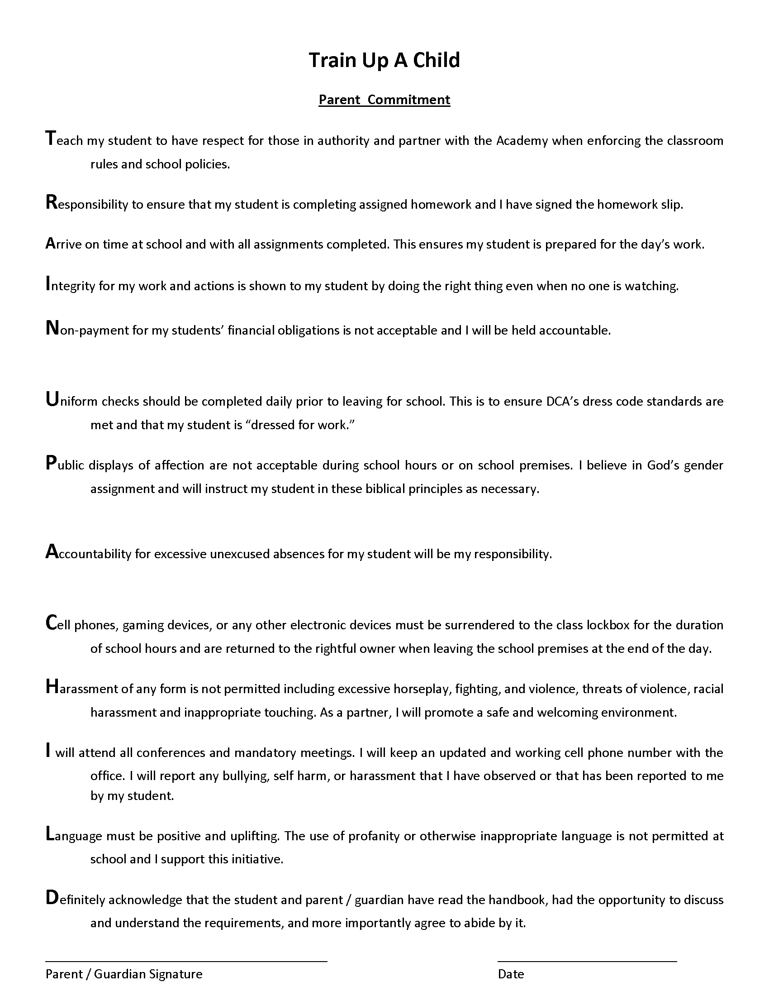

## Student Conduct Commitment

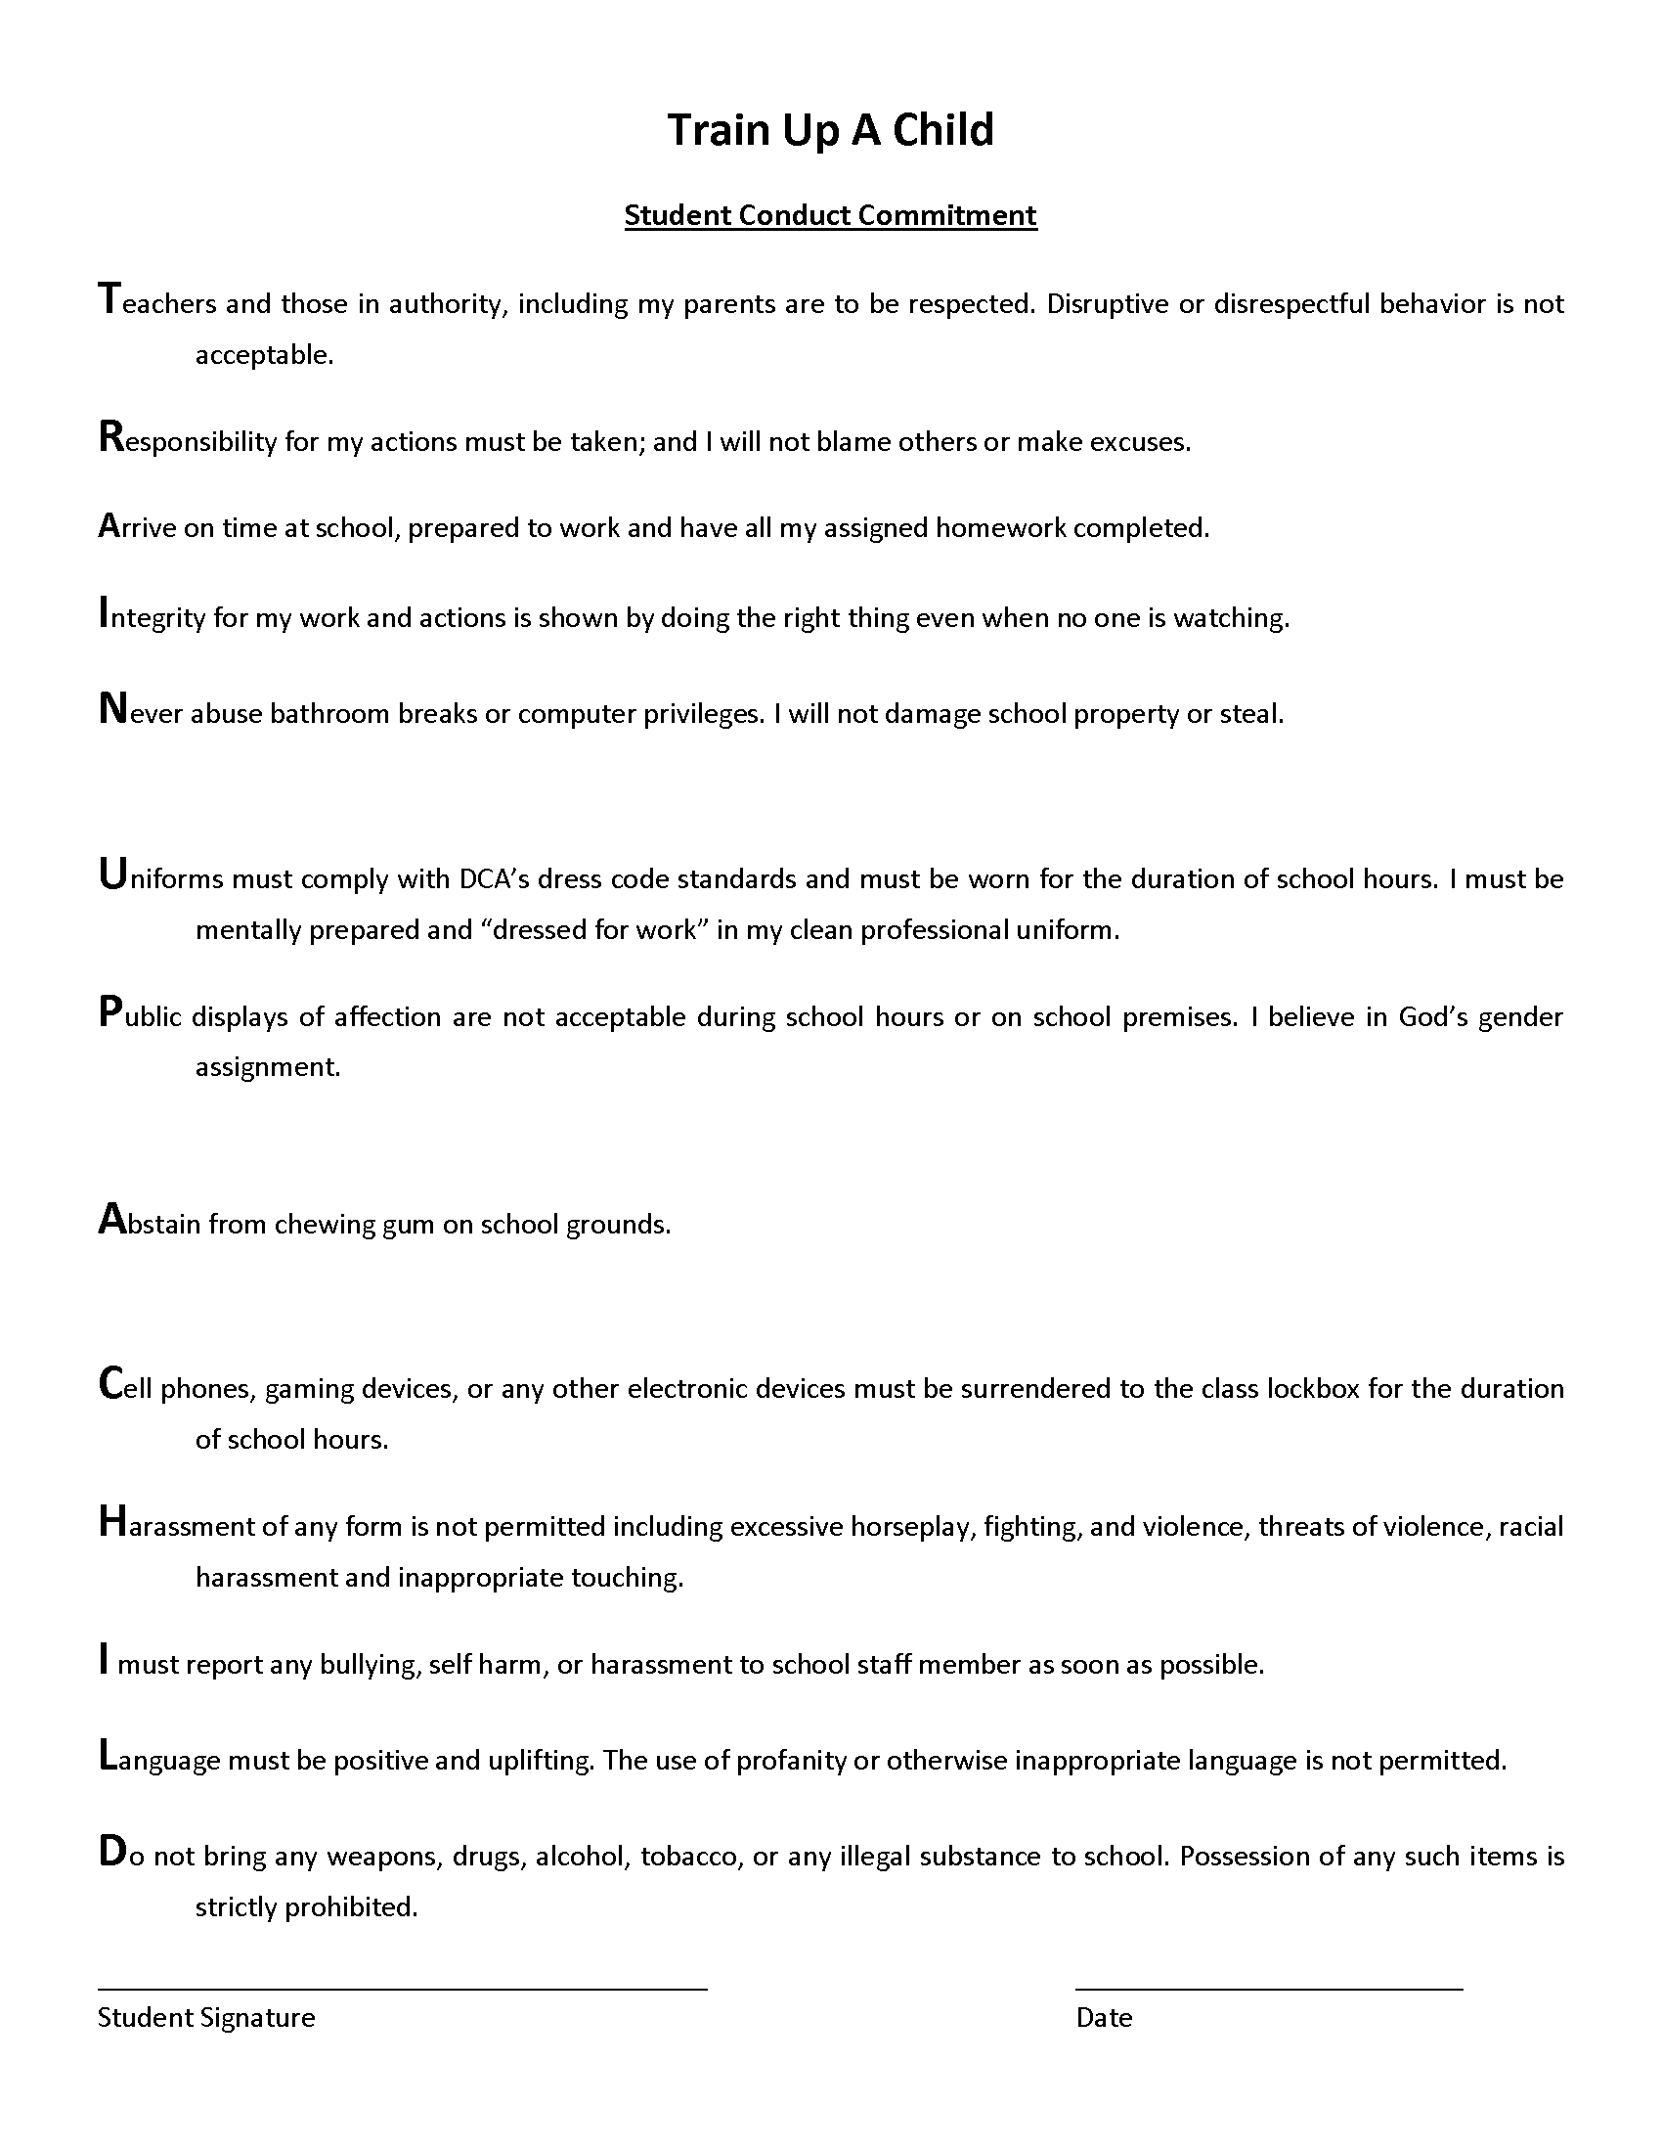

## Teacher / Monitor Conduct Commitment

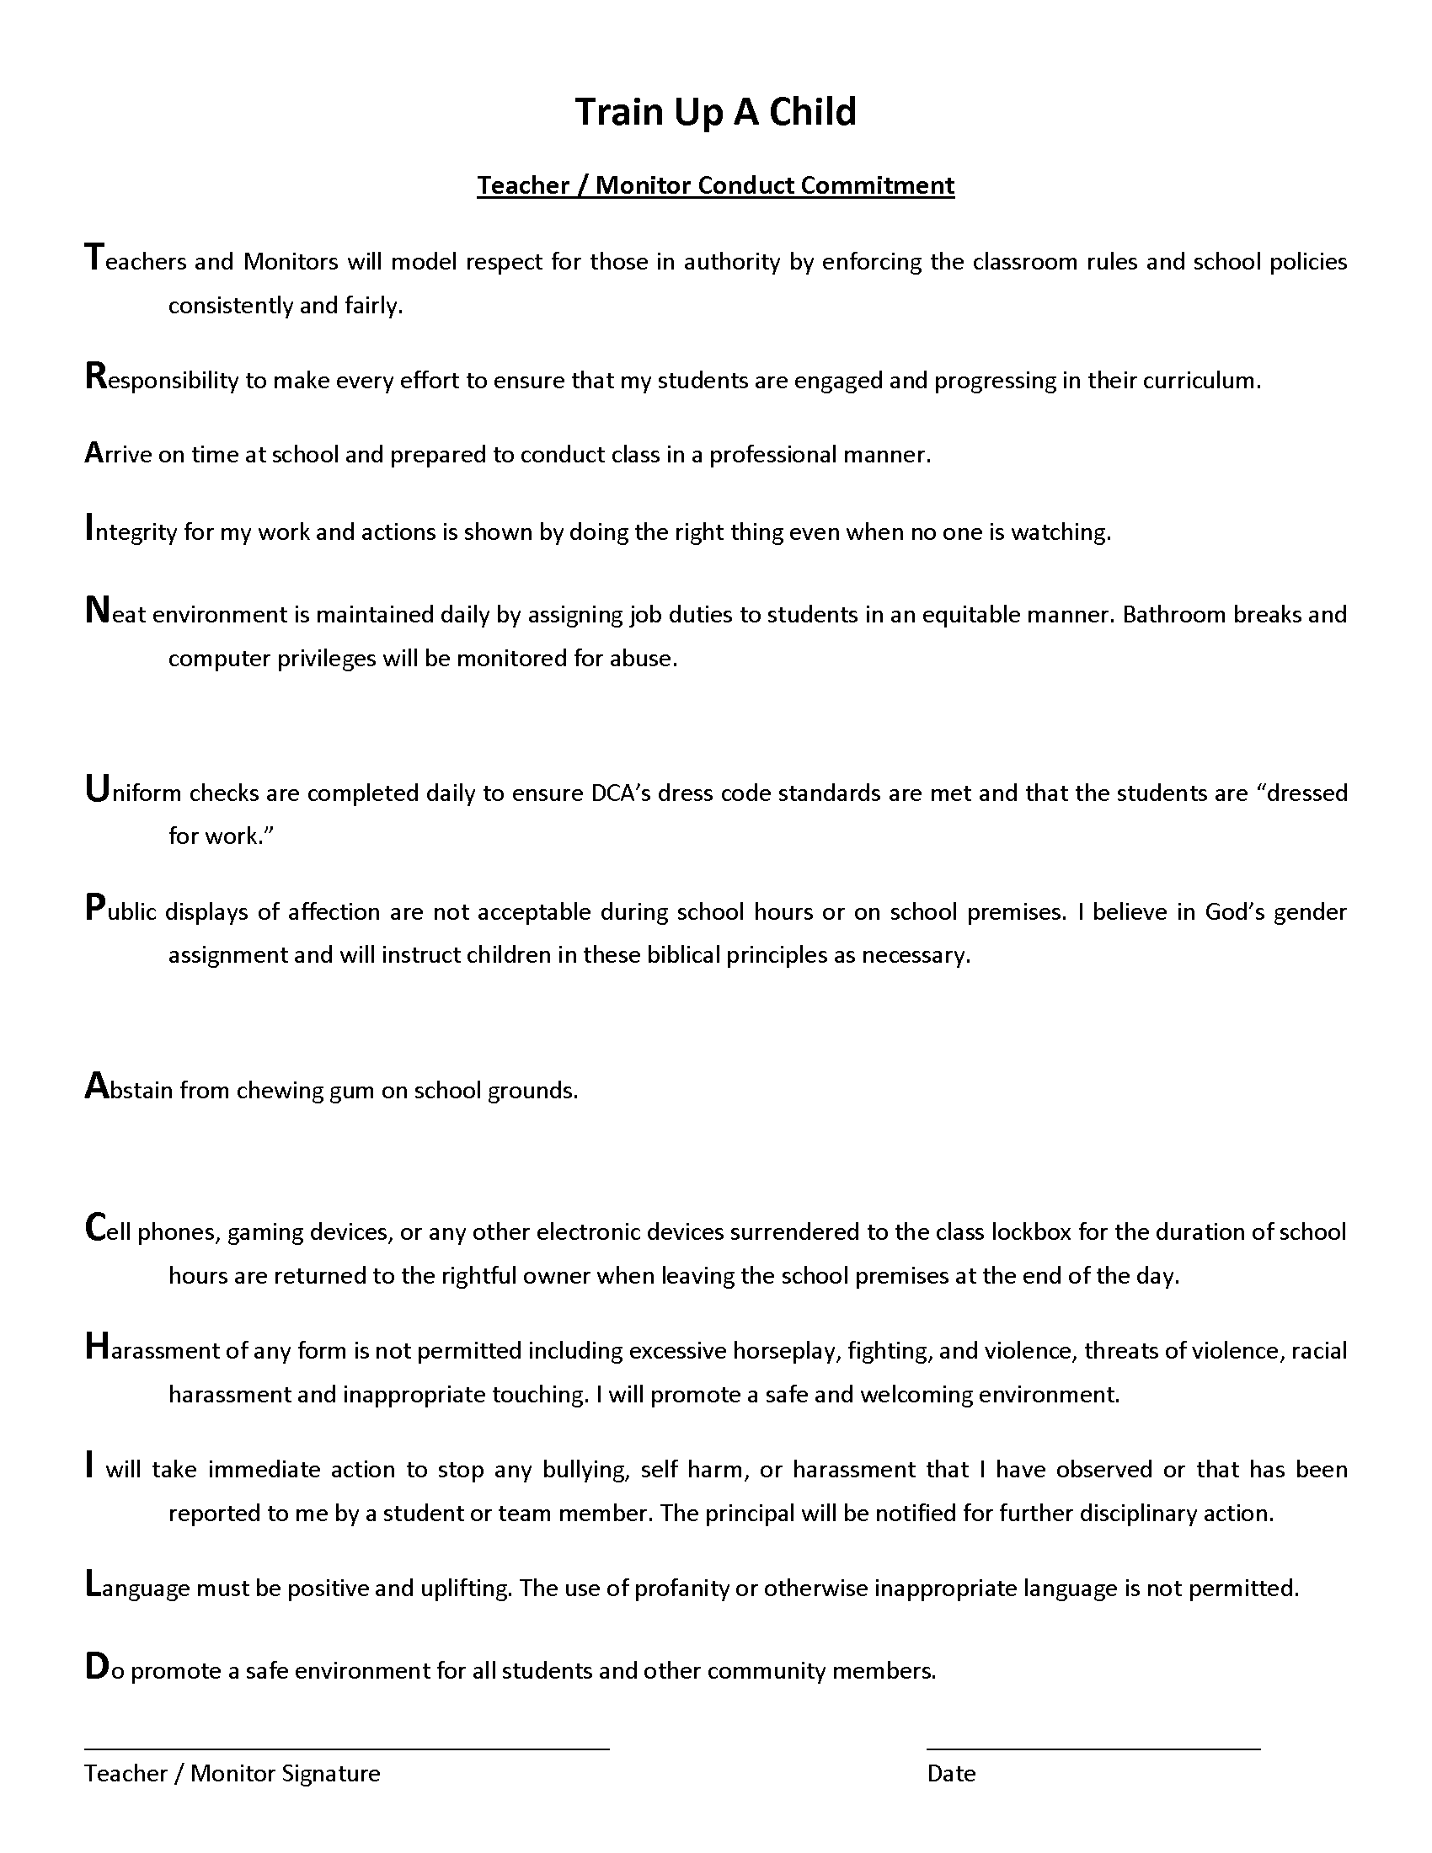

1. Lighthouse Christian Academy, Student Handbook, page 12